Table of Contents

1. Installation/Upgrade scripts 2

2. Configuration 3

3. Installation Java class for BAM 4

4. EM creation or modification 5

5. Update Dashboards 9

6. Update DataObject 9

# Installation/Upgrade scripts

This chapter explains how to install the script for the first time

* unzip bam.zip under /product/SCRIPTS/soa/;

# Configuration

This chapter explains the initial configuration script that should be done only once.

* Edit /product/Middleware/Oracle_SOA1/bam/config/BAMICommandConfig.xml in order to add username and password:

*<?xml version="1.0" encoding="UTF-8"?><BAMICommand>*

*<ADCServerName>localhost</ADCServerName>*

*<ADCServerPort>9001</ADCServerPort>*

*<Communication_Protocol>t3</Communication_Protocol>*

*<SensorFactory>oracle.bam.common.statistics.noop.SensorFactoryImpl</SensorFactory>*

*<GenericSatelliteChannelName>invm:topic/oracle.bam.messaging.systemobjectnotification</GenericSatelliteChannelName>*

***<ICommand_Default_User_Name>weblogic</ICommand_Default_User_Name><ICommand_Default_Password>current_weblogic_password </ICommand_Default_Password>***

*</BAMICommand>*

* configure envbam.sh under /product/SCRIPTS/soa/bam/ with the target env;
* run importDo.sh under /product/SCRIPTS/soa/bam/;
* run importAllChild.sh /product/SCRIPTS/soa/bam/;
* run importAllParent.sh /product/SCRIPTS/soa/bam/;

# Export Java class for BAM

This chapter explains how to export the java class

The java class is located under **/product/Middleware/Oracle_SOA1/soa/modules/oracle.soa.ext_11.1.1**

# Export EM

This chapter explains how to export the EM of BAm

***Not is possible to export EM of BAM***

Open Internet Explorer and go to this address **http://host:port/OracleBAM** like the screenshots below:

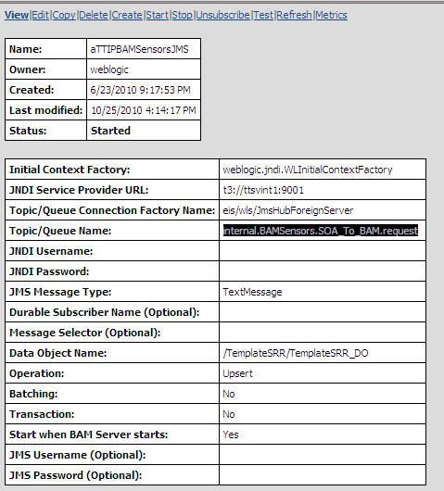

Change all **host** and port with name of host and port of your machine.

Click on Edit link

Copy from XSL transformation and create new text file with name **TrasfEM1.txt**

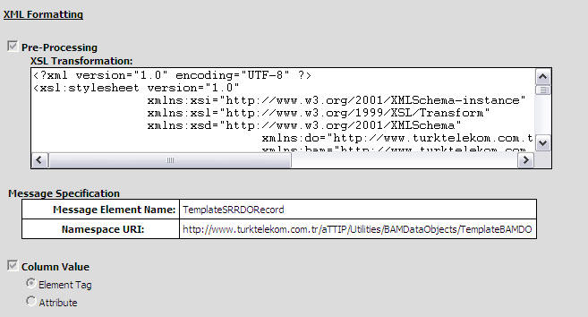

All steps must be performed also for SendDataToBAM EM source:

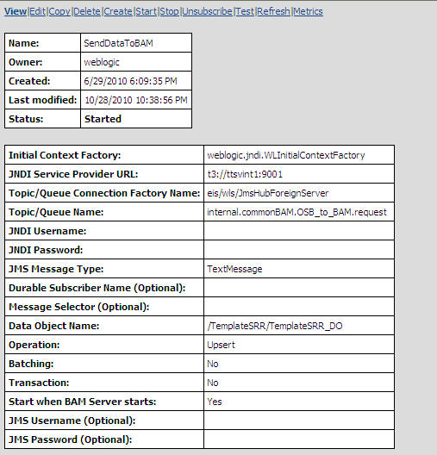

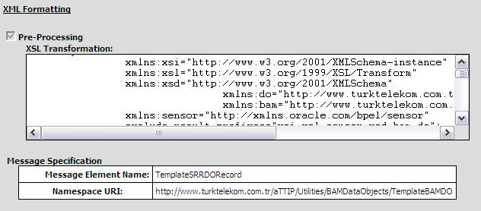

# Export Dashboards

This chapter explains how to export the dashboard from server

* If exists **/product/SCRIPTS/soa/bam/exp_report_parent** create backup, delete and recreate
* If exists /**product/SCRIPTS/soa/bam/exp_report_child** create backup, delete and recreate
* run exportAll.sh under /product/SCRIPTS/soa/bam/